

PRESS RELEASE Prague, 8th August 2017

Kinobus coming to BB Centrum

Film fans and summer cinema devotees can come to BB Centrum in Prague 4 to see selected Czech and foreign productions, free of charge. The mobile Kinobus summer cinema will be stopping on U Michelské školy Street, in the immediate vicinity of Baarův Park, from 14 to 17 August. The projects begin at 9 p.m. and the programme will include the animated film Zootopia, the Czech films All or Nothing (Všechno nebo nic) and River Rascals (Špunti na vodě) and the French drama Polina.

Starting from Monday 14 August the popular Kinobus will be unfurling its projection screen in BB Centrum and it welcomes everyone who would enjoy a good film under a summer evening sky. Four successful films will be screened each evening from 14 to 17 August 2017 on U Michelské školy Street in BB Centrum (by the tallest building FILADELFIE) in Prague 4 – Michle from about 9 p.m.

Comfortable benches will be prepared for the viewers and there will also be classic “film” refreshments for the perfect cinematic experience.

You can find the Kinobus’ complete programme and stops here, and new and current information about events in BB Centrum in here.

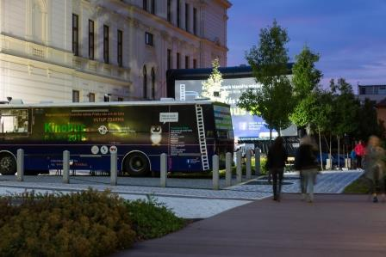

Kinobus in BB Centrum

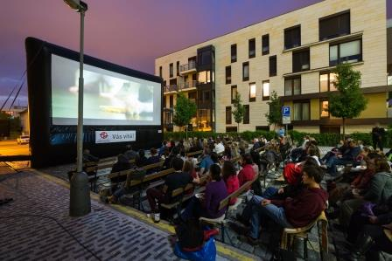

Kinobus in BB Centrum

For more information and photographs in print quality please contact:

Kristýna Samková, Head of PR and Marketing dept.
PASSERINVEST GROUP, a.s.
Tel.: (+420) 221 582 111
Mobil: (+420) 602 186 708
E-mail: Kristyna.Samkova@Passerinvest.cz
www.passerinvest.cz, www.bbcentrum.cz

Marcela Štefcová
Crest Communications a.s.
Mobile: (+420) 731 613 669
E-mail: marcela.stefcova@crestcom.cz
www.crestcom.cz

ABOUT THE DEVELOPER

PASSERINVEST GROUP, a. s., is a purely Czech development company, whose name is primarily connected with the construction of the multifunctional BB Centrum complex in Prague 4 – Michle. The company, founded in 1991 by Radim Passer, built a very good name on both a domestic and international level with this, the most successful and extensive Czech project of its kind. This is not only due to the quality of the implemented projects and the high level of provided services, but also to a sense of fair play, an accommodating relationship with the tenants/users of the buildings and the responsibility towards society and the environment. PASSERINVEST GROUP also has other interesting development projects in its portfolio.

